

System Admin

Training Assignments

|  |  |
| --- | --- |
| Program Code |  |
| Issue/Revision | x/y |
| Effective date | 04/Aug /2023 |

Assignment Day 11. Monitoring and Alerting

Contents:

Hướng dẫn cài đặt và cấu hình Zabbix cho giám sát hệ điều hành 2

Installing Zabbix Server 3

Step 1: Pre-requisites 3

Step 2: Installing LAMP Server 3

Step 3: Creating a Database for Zabbix 4

Step 4: Install Zabbix Server 4

Step 5: Configuring the Zabbix Agent. 5

Step 6: Config DashBoard 6

Installing Zabbix Agent and connect to Zabbix Server 7

Step 1: Enable Zabbix repository on remote host 7

Step 2: Install Zabbix agent 7

Step 3: Configure Zabbix agent 8

Step 4: Configure the firewall 8

Step 5: Add host on Zabbix server 9

Alerting Setup 14

Slack Setup 14

Zabbix Setup 20

Testing 27

# Install and Configure Zabbix Guide

# Installing Zabbix Server

## Step 1: Pre-requisites

After you logged in to your server you need to update to the latest available packages.

# apt-get update -y

## Step 2: Installing LAMP Server

Firstly we need to install Apache and MySQL server.

# apt install apache2 -y  
# apt install mysql-server -y

Check if apache2 and mysql-server is runing.

# systemctl status apache2

# systemctl status mysql-server

## Step 3: Install Zabbix Server

Zabbix is not installed in the Ubuntu 20.04 standard repository by default so we need to install the repository first.

#wget https://repo.zabbix.com/zabbix/6.0/ubuntu/pool/main/z/zabbix-release/zabbix-release_6.0-4+ubuntu22.04_all.deb

#dpkg -i zabbix-release_6.0-4+ubuntu22.04_all.deb

Now we need to update the repository and install the Zabbix server.

#apt-get update  
#apt install zabbix-server-mysql zabbix-frontend-php zabbix-apache-conf zabbix-sql-scripts zabbix-agent -y

Check if Zabbix-server is running.

#systemctl status zabbix-server

## Step 4: Creating a Database for Zabbix

Now we need to create a database and user for Zabbix.

#mysql -uroot -p

password *# change password to your own password - this is password for "root" user.*

mysql> create database zabbix character set utf8mb4 collate utf8mb4_bin;

mysql> create user zabbix@localhost identified by 'password'; *#change password to your own password - this is password for "zabbix" user.*

mysql> grant all privileges on zabbix.* to zabbix@localhost;

mysql> set global log_bin_trust_function_creators = 1;

mysql> quit;

On Zabbix server host import initial schema and data. You will be prompted to enter your newly created password for “zabbix” user.

zcat /usr/share/zabbix-sql-scripts/mysql/server.sql.gz | mysql --default-character-set=utf8mb4 -uzabbix -p zabbix # wait a couple of mins.

Disable log_bin_trust_function_creators option after importing database schema.

# mysql -uroot -p

password

mysql> set global log_bin_trust_function_creators = 0;

mysql> quit;  
Step 5: Configure database for Zabbix server and start Zabbix service.

Edit file /etc/zabbix/zabbix_server.conf

# vi /etc/zabbix/zabbix_server.conf

#Edit this line bellow with your “zabbix” user password

DBPassword=password

Apply new configure and enable Zabbix services  
# systemctl restart zabbix-server zabbix-agent apache2

# systemctl enable zabbix-server zabbix-agent apache2

## Step 6: Config DashBoard

Enter the Zabbix dashboard via [**http://YOUR-SERVER-IP/zabbix**](http://YOUR-SERVER-IP/zabbix) You will be redirected to the Zabbix welcome page.

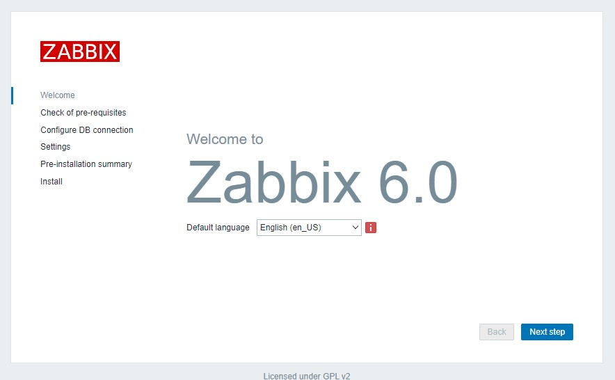

Click on **Next** Check if all the pre-requisites are installed.

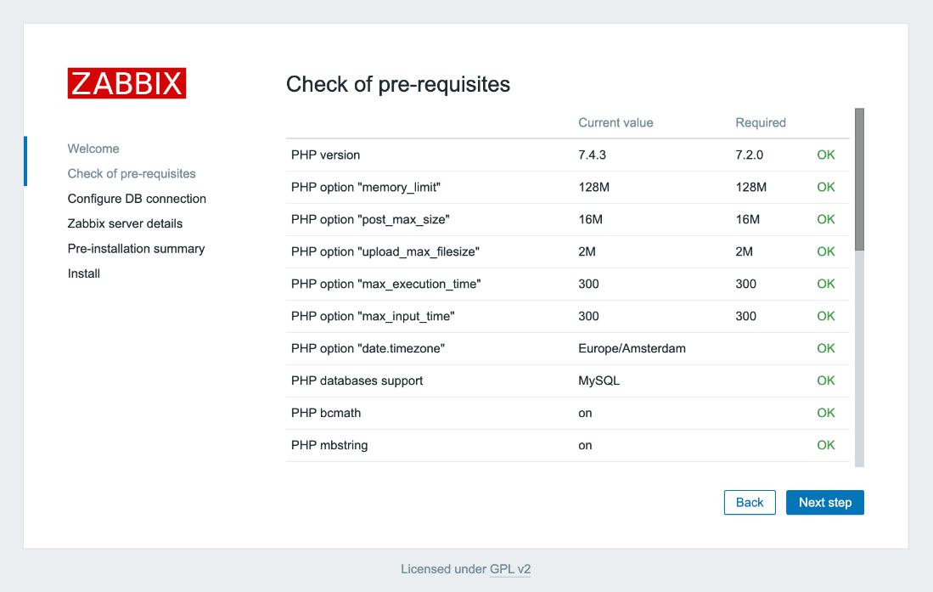

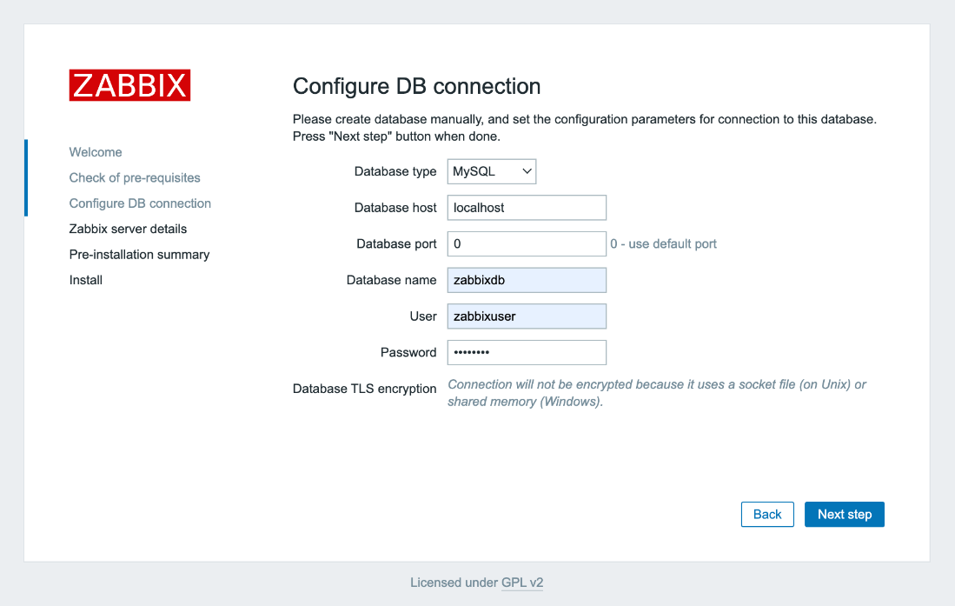If every pre-requisites is installed you can click **Next**. Next we need to enter the database credentials we have created earlier.

Next you need to provide your Zabbix server details. In the example we use **Demo** as the name.

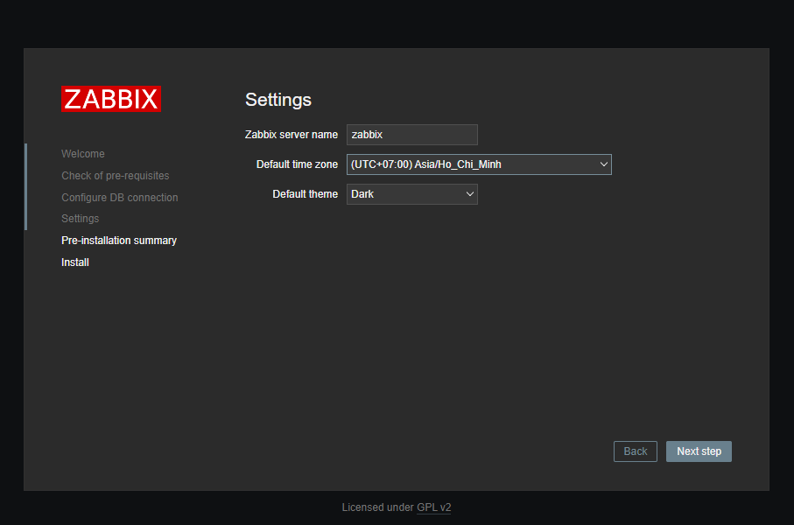

Next you need to confirm the configuration.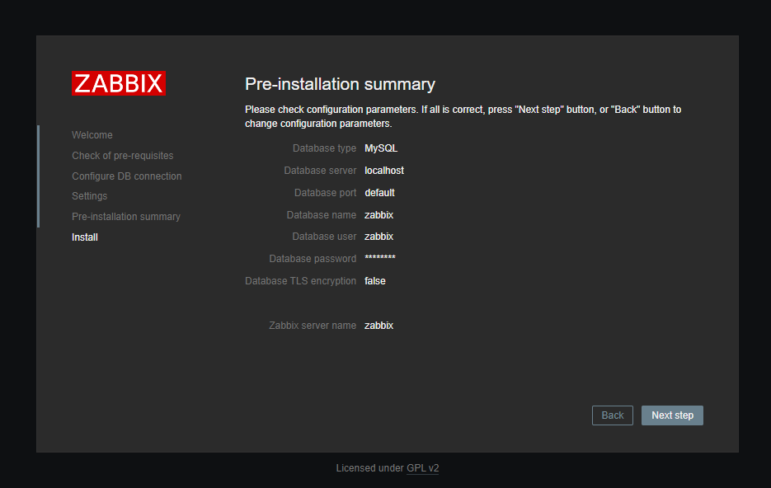

A screen saying **Congratulations!** will follow. Click **Finish**

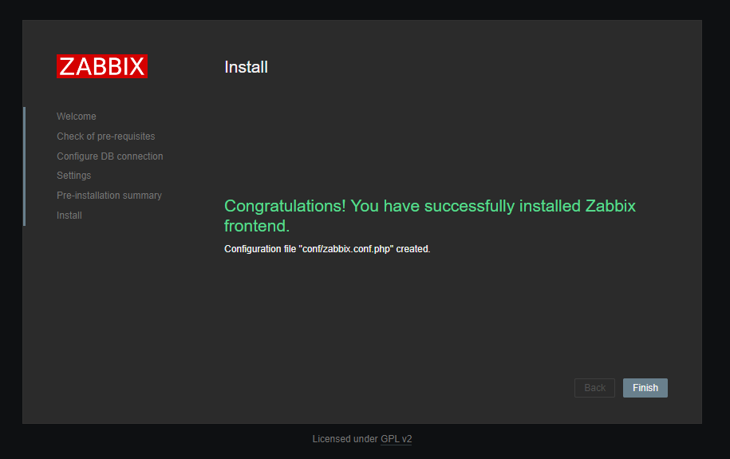

You will be redirected to the Zabbix login page. The Zabbix default username and password are the following:

**Username** = Admin **Password** = zabbix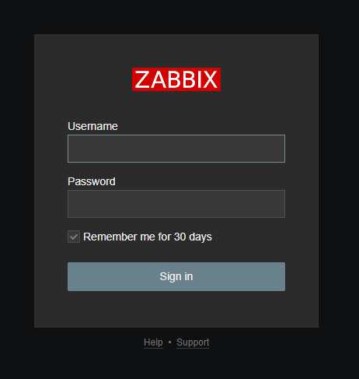

You have now successfully installed Zabbix Server.

# Installing Zabbix Agent and connect to Zabbix Server

Zabbix agent is installed on the remote host (target) to monitor the hard drive, memory processor, etc. The agent collects data and sends back to Zabbix Server.

Zabbix agents can use **passive** or **active** checks to pass information. In **passive** check, Zabbix server (poller) requests an agent for certain information, and the agent sends back a value. In the **active check**, the agent process all data and pushes it to the Zabbix server. However, agent periodically connects the server to collect metric which needs to be monitored.

We will begin by **installing Zabbix agent** to the remote **Ubuntu 20.04** host and later add a host to Zabbix server dashboard.

## Step 1: Enable Zabbix repository on remote host

Begin by updating the package lists on the remote host.

sudo apt update

Then download the Zabbix repository Debian file from [Zabbix download center](https://www.zabbix.com/download?zabbix=5.0&os_distribution=ubuntu&os_version=20.04_focal&db=mysql&ws=apache) as follows.

wget <https://repo.zabbix.com/zabbix/5.0/ubuntu/pool/main/z/zabbix-release/zabbix-release_5.0-1+focal_all.deb>

Then enable it using the **dpkg** command as follows:

sudo dpkg -i zabbix-release_5.0-1+focal_all.deb

Next, update the package index to ensure the repository is synced

sudo apt update

## Step 2: Install Zabbix agent

Once the repository is in place, install Zabbix agent.

sudo apt install zabbix-agent

Once the installation is complete, check whether the Zabbix-agent daemon is running as follows:

sudo systemctl status zabbix-agent

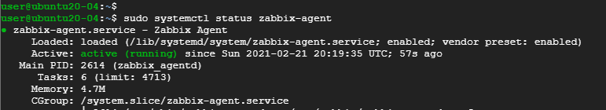check status of zabbix-agent

Zabbix-agent [listens to port](https://linuxopsys.com/topics/check-ports-in-use-in-linux) **10050**. You might want to confirm this using the netstat command:

sudo netstat -pnltu

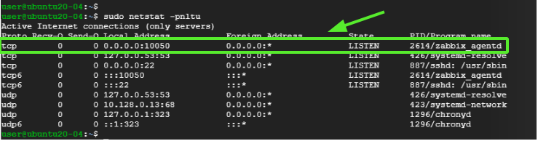check port zabbix agent is listening on

The image above is a confirmation that Zabbix agent service is up and running.

## Step 3: Configure Zabbix agent

We are satisfied that the Zabbix agent is running as expected. But that is not enough. We need to make a few changes to the configuration file at **/etc/zabbix/zabbix_agentd.conf** so that Zabbix agent can communicate with the Zabbix server.

So open the file.

sudo vim /etc/zabbix/zabbix_agentd.conf

Here we are going to **enable passive checks** on the agent. First, locate the variable "Server" and "Hostname" in the zabbix_agentd.conf file.

For example, My Zabbix server IP is 10.128.0.16 and the hostname (client system) is ubuntu-20.

Server=10.128.0.16

Hostname=ubuntu-20

Save the changes and exit the file. Then restart Zabbix agent service to the changes to be effected.

sudo systemctl restart zabbix-agent

Note if you are configure **active check** then look for the variable "ServerActive" and uses port 10051.

## Step 4: Configure the firewall

The final step in configuring the host is allowing the port that Zabbix agent listens to across the firewall. If you have UFW firewall enables, execute the commands:

sudo ufw allow 10050/tcp

Then reload the firewall

sudo ufw reload

And verify that the port has been opened or allowed on the firewall.

sudo ufw status

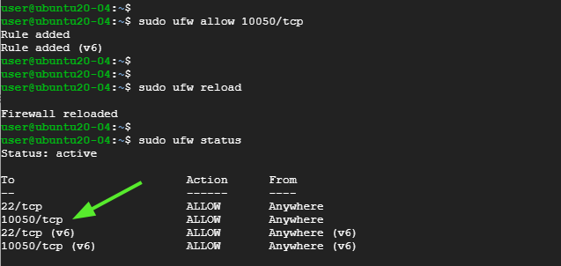configure firewall to allow zabbix agent port 10050

Perfect! The zabbix-agent should now be in a position to communicate with the server.

## Step 5: Add host on Zabbix server

By default, Zabbix only monitors the server on which it is installed. In this section, we will be adding the Zabbix host on the Zabbix server on the browser.

So, login in to your instance of Zabbix Server on the browser.

On the left navigation pane, Click on **Configuration** > **Hosts**

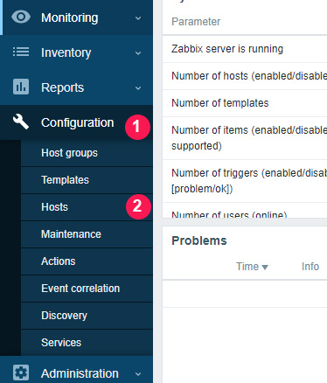

Navigate to the top-right corner and click on **'Create host**'

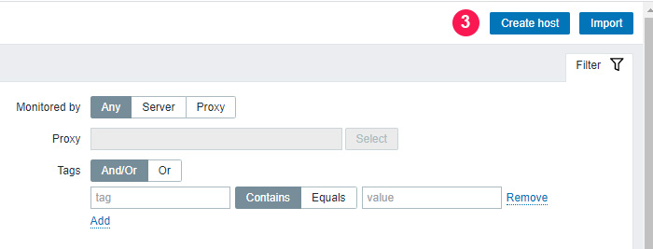On the window that appears, fill out the remote host details such as hostname. visible name, IP address, a brief description and click on the '**Select**' button adjacent to the 'Groups' text field.

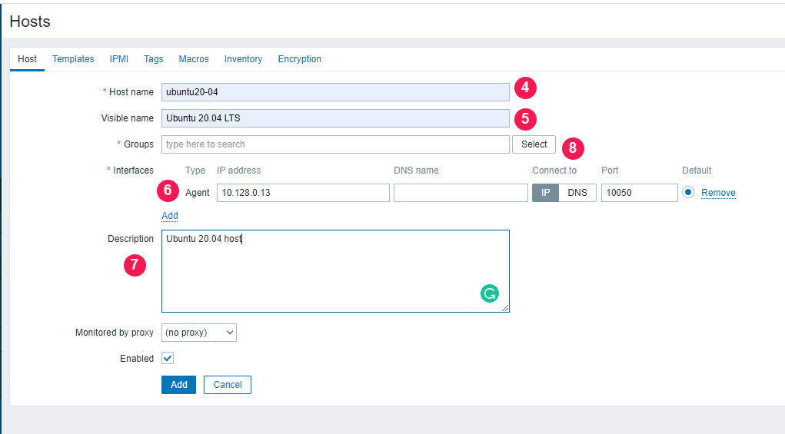

On the list that appears , select '**Linux servers**' and click on the '**Select**' button.

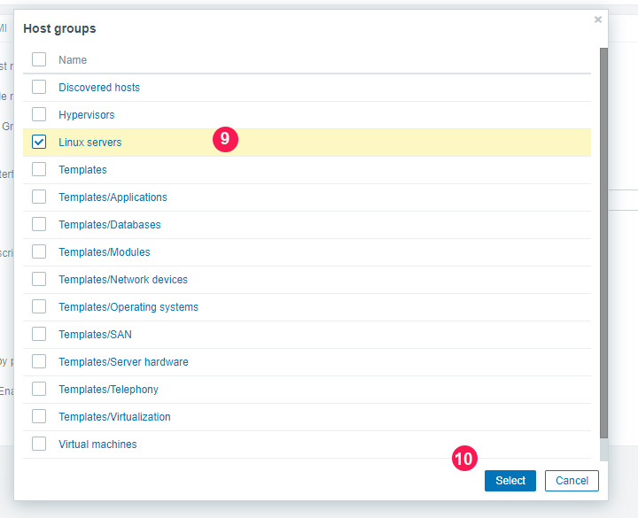

This takes you back and you can view the newly added group as indicated.

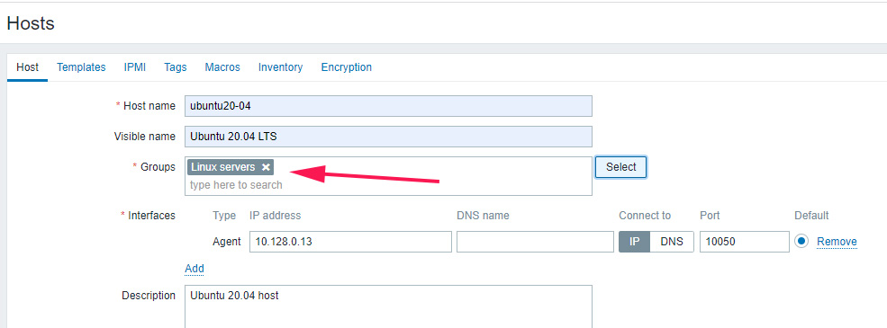Next, click on the '**Templates**' tab and click the '**Select**' button adjacent to the **'Link new Templates**' text field.

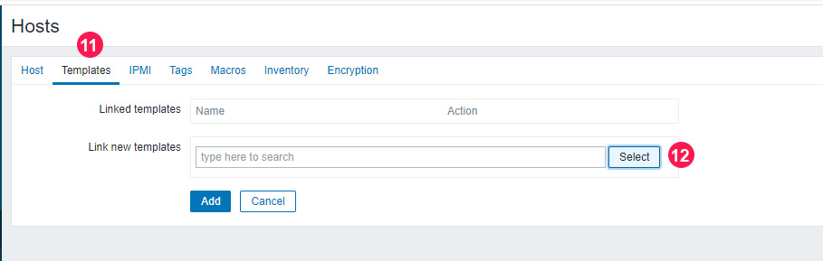

Click on the '**Select**' button next to the '**Host group**' text field as shown.

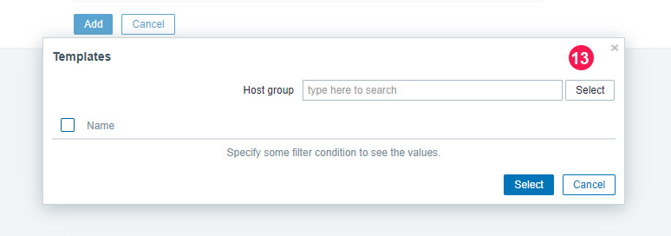Click on the '**Templates/Operating systems'** option as shown.

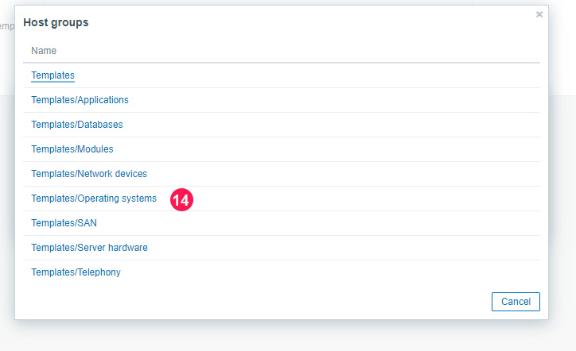Then select the '**Template OS Linux by Zabbix agent'** option and click on '**Select**'.

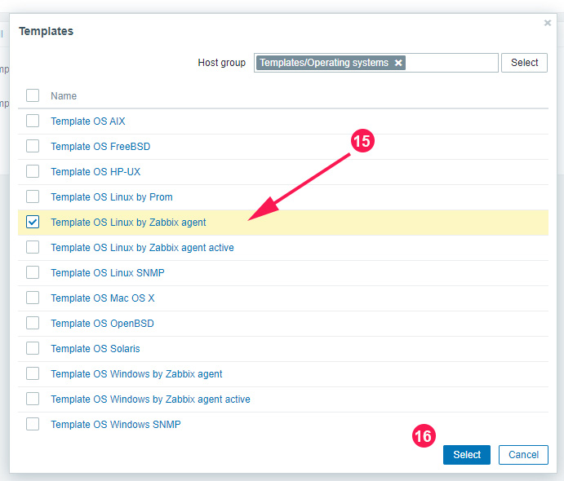

Then finally, click on the '**Add'** button.

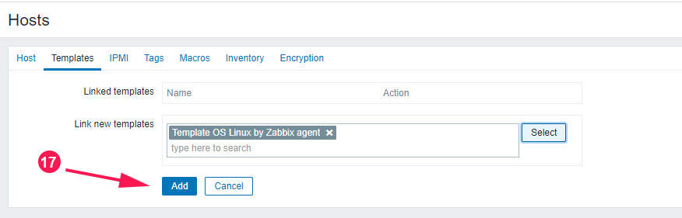And your host will be listed on the dashboard as shown.

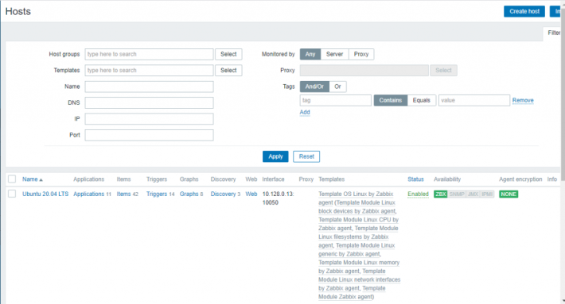

Done!

# Alerting Setup

## Slack Setup

The first step is to create an App and retrieve a Slack bot token. Slack’s API works really well but if your workplace has been in use for years it can be frustrating to find the correct page that has the information you need. They seem to have changed their API a few times and it’s not very clear which page you need to go to for which tokens, and what those tokens specifically do. I’ll try to make it clear in these instructions.

Start at <https://api.slack.com/apps>. You will need to login to your Workplace if you are not logged in already. When logged in, the page should look like this:

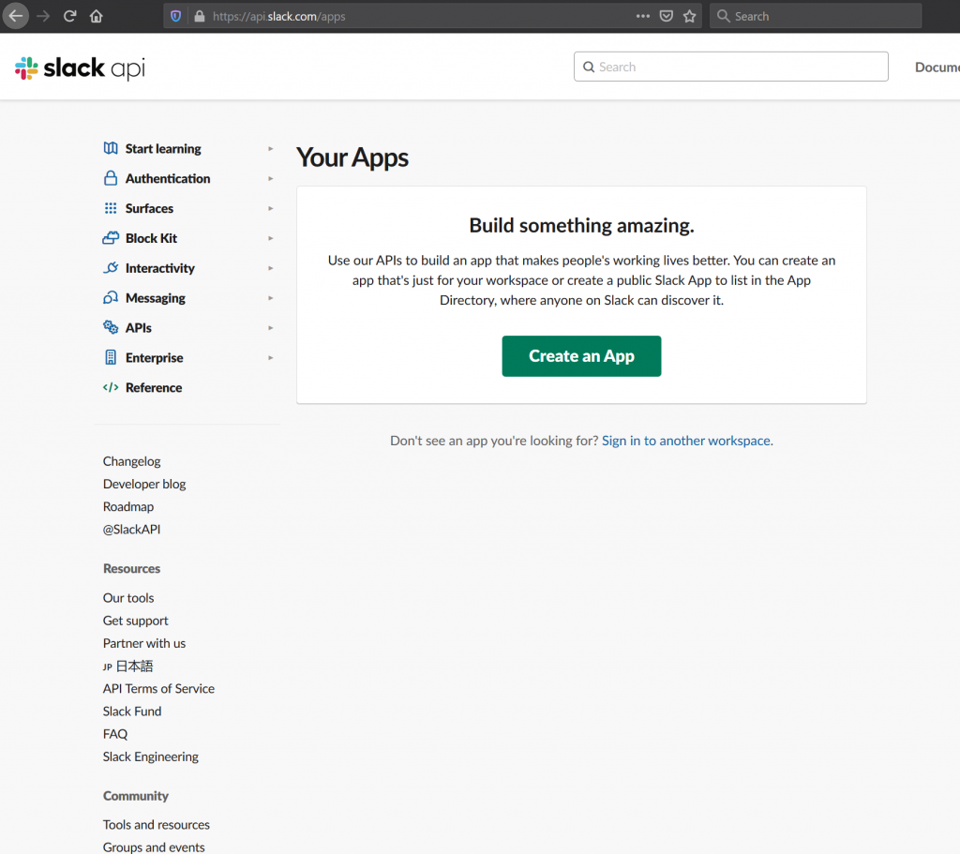

Click on Create an App. Name the app Zabbix Alerts or something similar:

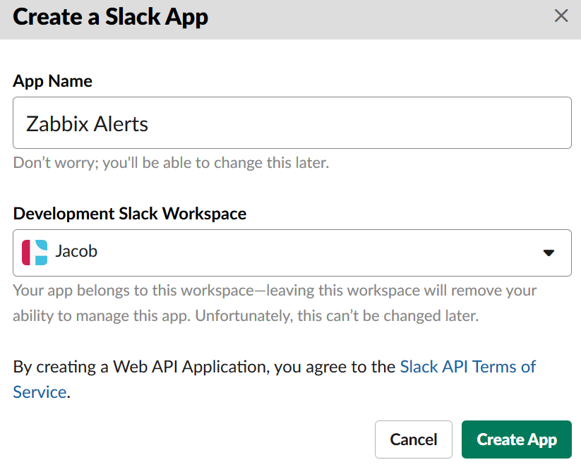

It should take you to the Basic Information for your new app:

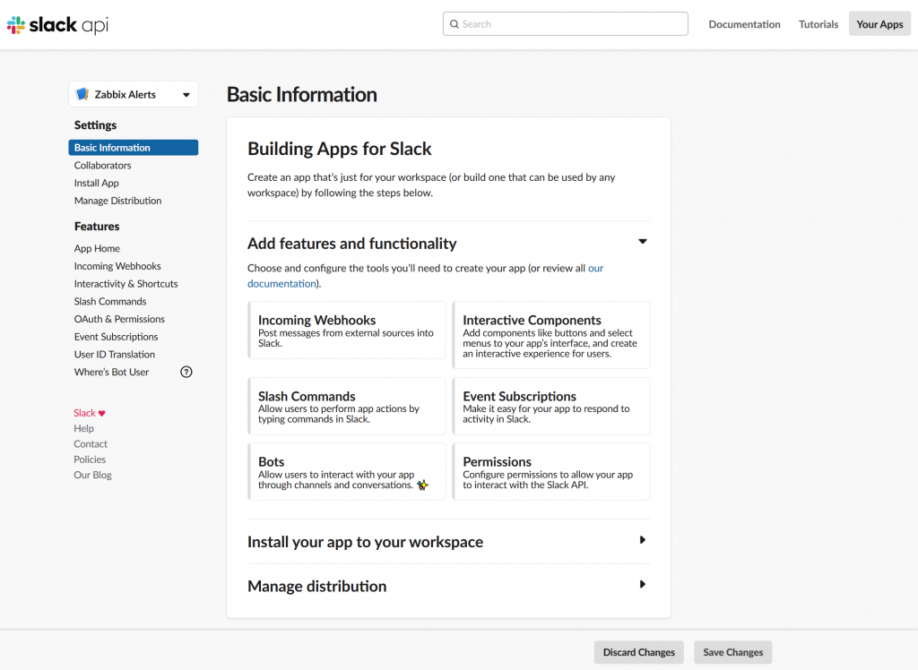

Click on “Bots” on the bottom left. Now you are directed to App Home (which is not the Bots page):

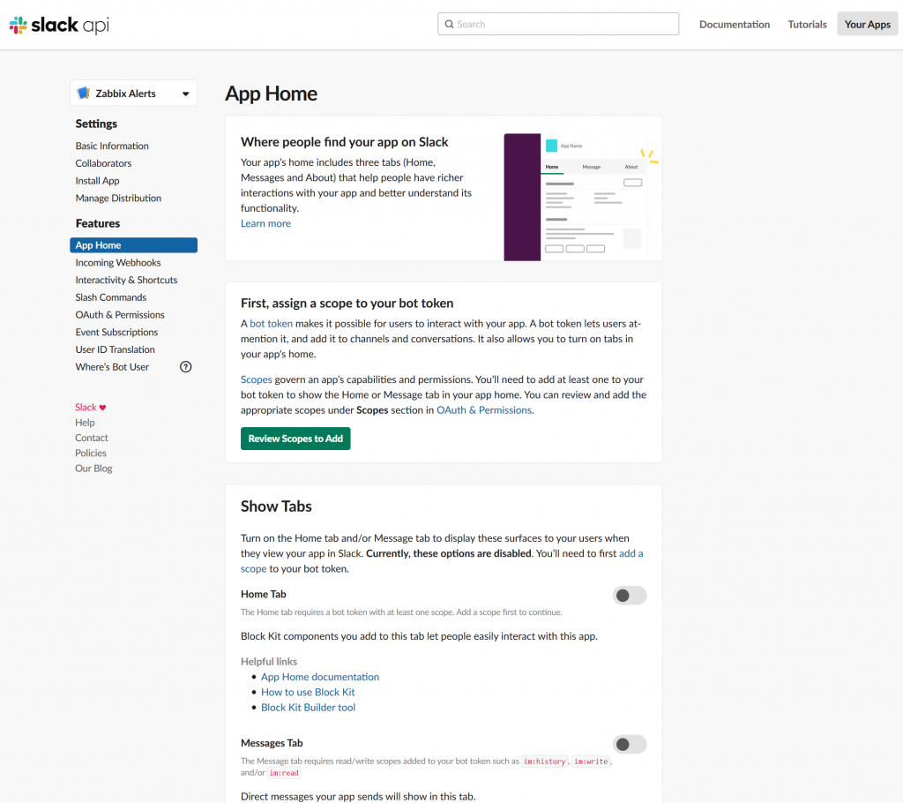

If you click on the “[bot token](https://api.slack.com/authentication/token-types#bot)” link you won’t be directed to the Bot Tokens, you will be brought to the documentation on what a Bot user is. The most important thing to know from that page is:

Bot user token strings begin with xoxb-

Alright so now you are probably starting to see what I meant with Slacks API sites being frustrating.

Make sure you are on the App Home page shown above, then click on the green box that says “Review Scopes to Add”. You should be directed to the OAuth & Permissions page:

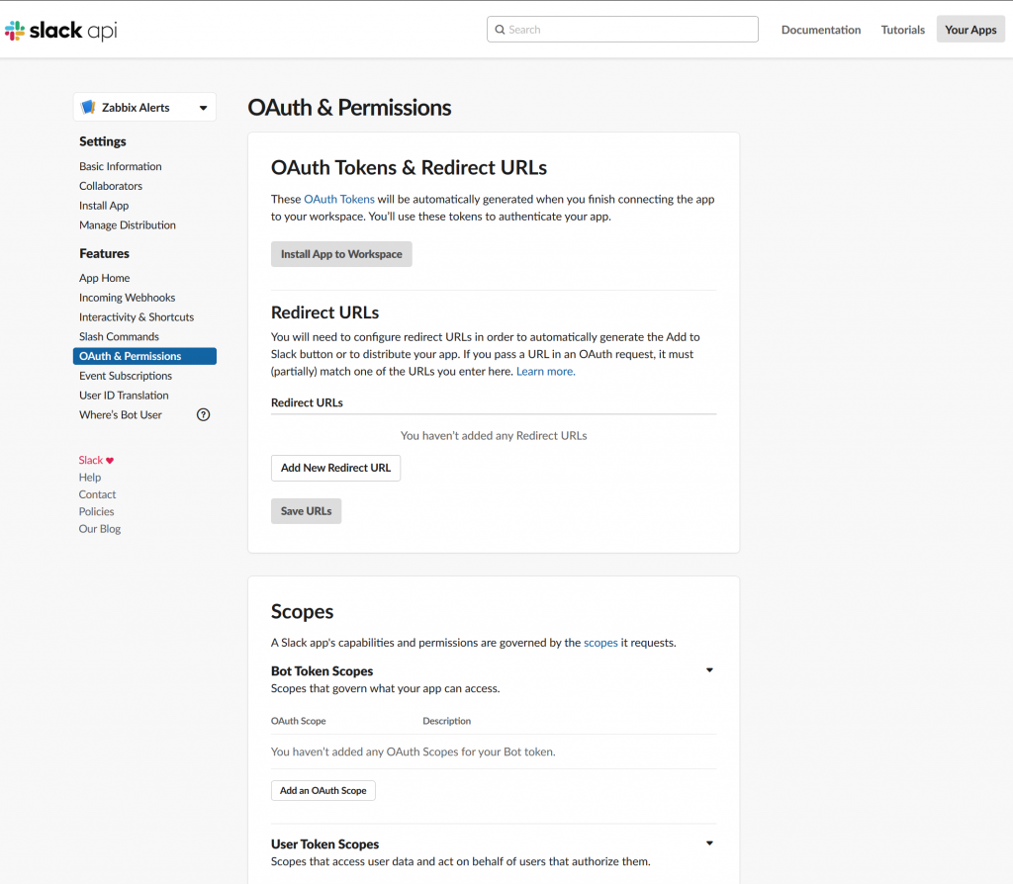

Under Bot Token Scopes add an OAuth Scope of “chat:write”:

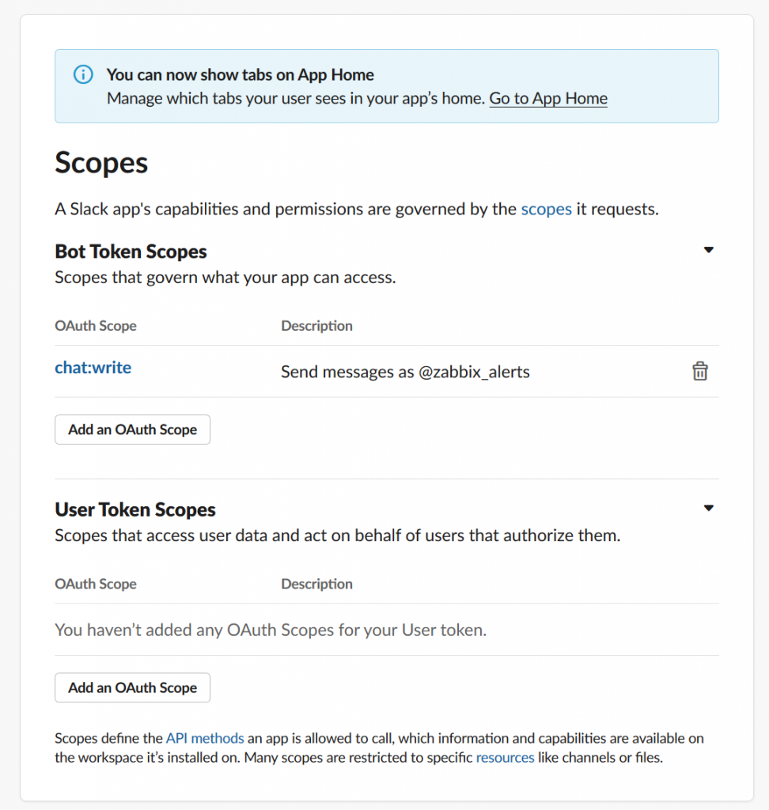

Now that the Bot Token has a scope, the “Install App in Workplace” button located on the same page (OAuth & Permissions) should be green. Click on it and it should redirect you to a page, then be redirected back to the OAuth & Permissions page, but now you have a Bot User OAuth Access Token:

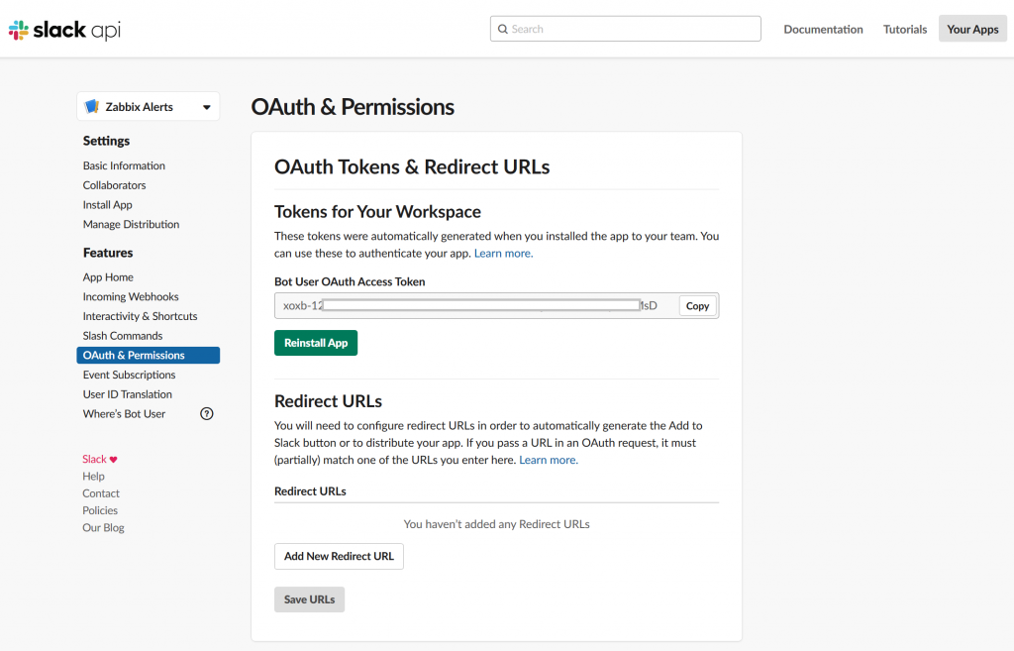

The last step is to create a test Slack channel and add the app. Open Slack and create a channel named zabbix-test or whatever you want to name it:

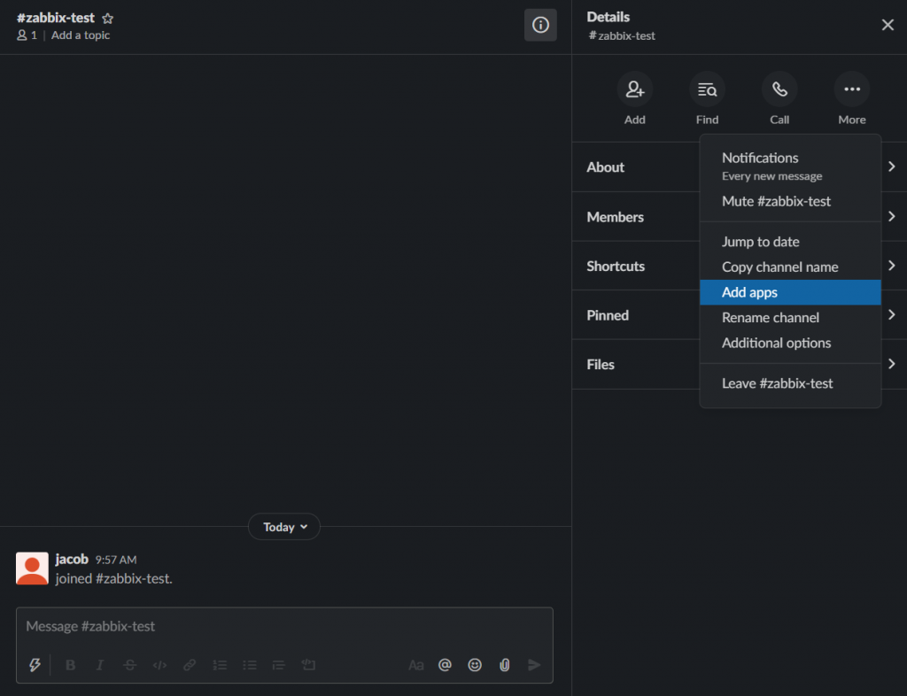

Since Slack is so intuitive you have to click the **(i) Details** button in the top right corner of the channel box, then click More, then click Add apps. From there you can select your Zabbix Alerts app:

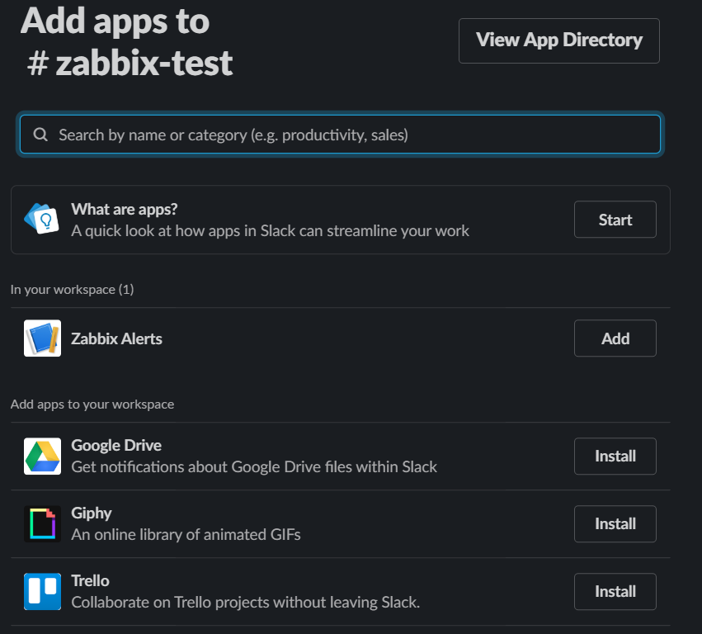

When you click Add it will say something about Zabbix Alerts in the main chat area:



That should be all that is required for Slack setup. Everything else is on Zabbix now.

## Zabbix Setup

I highly, highly recommend considering updating to Zabbix 5.0+ for the sole reason that it allows for secret macros. The official documentation for Zabbix 4.4 Slack integration allows any user with access to global macros to see the bot token in plain text.

The first step is to navigate to **Administration > Media Types** and use the Import button in the top right corner to upload this [media_slack.xml](https://git.zabbix.com/projects/ZBX/repos/zabbix/browse/templates/media/slack/media_slack.xml) file:

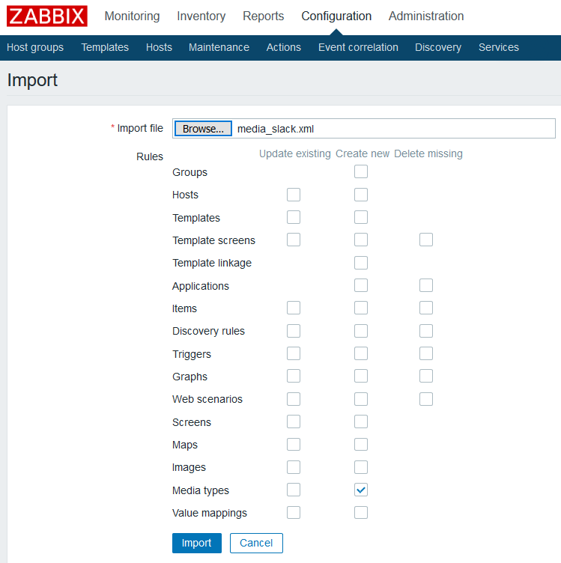

You will probably run into the problem where you downloaded media_slack.xml for the latest version of Zabbix 5.0 and Zabbix GIT makes you register to view a previous version. Make sure you use a “release” version or it probably won’t work right. Here is a direct download to a version for release Zabbix 4.4 that should work :

[media_slack44](https://monitoreverything.net/wp-content/uploads/2020/06/media_slack44.xml)

[Download](https://monitoreverything.net/wp-content/uploads/2020/06/media_slack44.xml) : <https://monitoreverything.net/wp-content/uploads/2020/06/media_slack44.xml>

If you are getting an error like shown below it means your media_slack.xml file is not the correct version. There is some JavaScript that is slightly tweaked between versions for everything to mesh correctly.

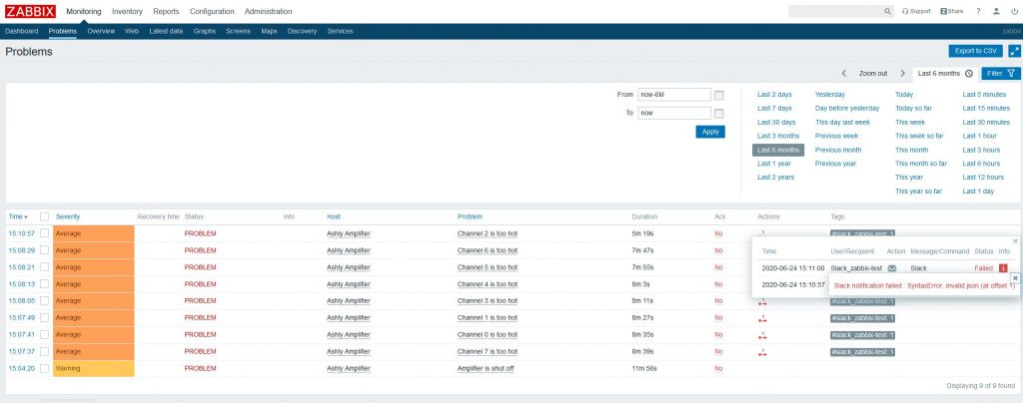Error when media_slack.xml is wrong version for Zabbix

Once you upload that, there should be a green bar at the top of the screen that says success, then navigate back to the **Media types** page and select Slack. You should be presented with many fields:

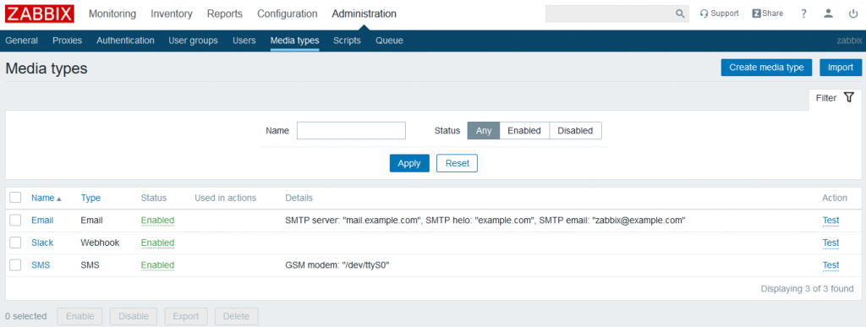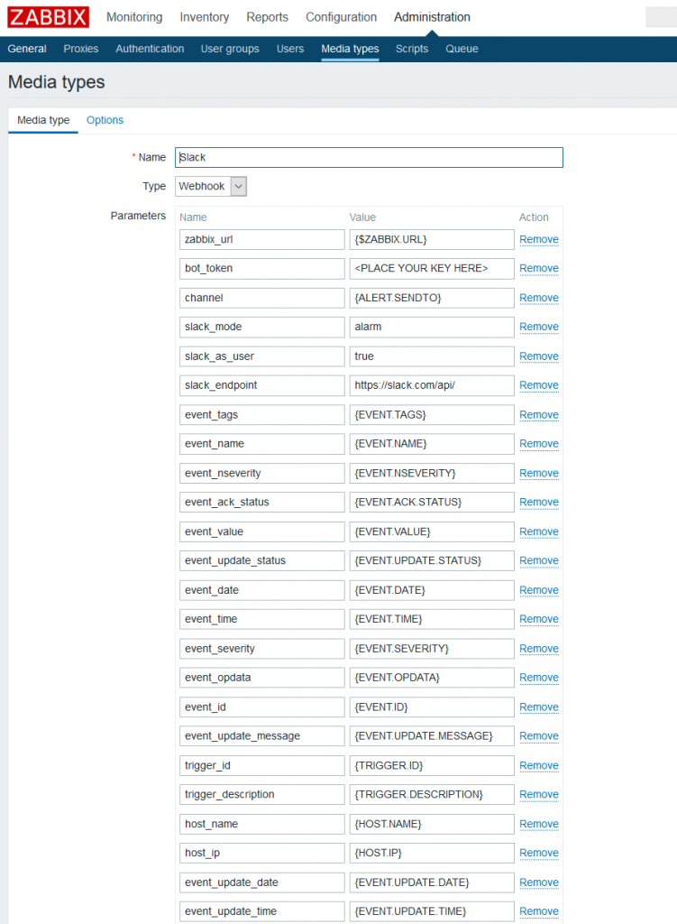Many fields

The official documentation says to store the token in bot_token but I set it as a global macro:

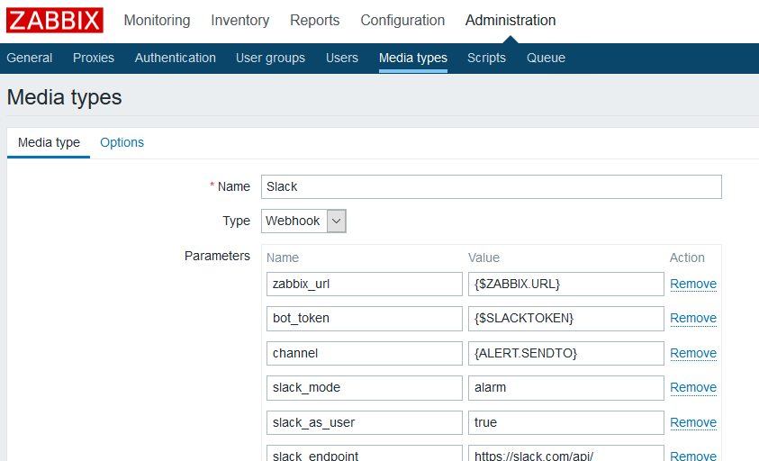bot_token is set for {$SLACKTOKEN}

Remember to scroll to the bottom and click Update when you make any updates.

Update those macros now, navigate to **Administration > General** and in the top right corner a drop down box will take you to Macros:

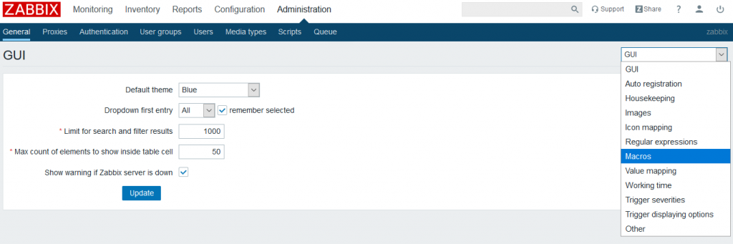

Set your macros for {$ZABBIX.URL} and {$SLACKTOKEN}:

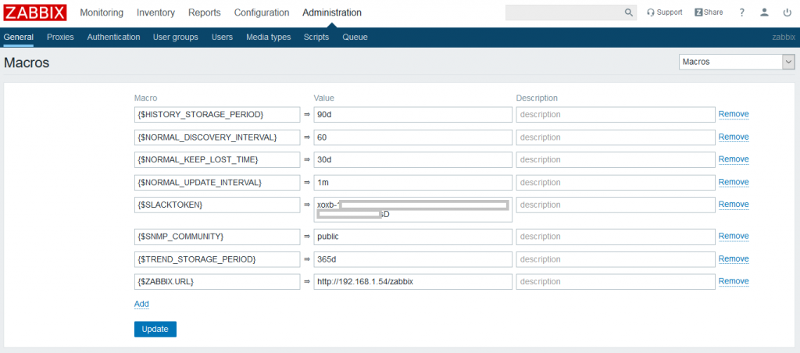

{$ZABBIX.URL} just tells the media where your Zabbix server is. The notifications sent to Slack will not direct users to the correct URL if you set this to 127.0.0.1. I’m not sure why they recommend that in the official documentation.

Copy your bot token directly from Slack into the macro value. If you are using Zabbix 5.0+ you can set this macro to be secret and it’s much safer.

Now just navigate to **Adminstration > Users**. You will need to create a user for every channel or direct message that is used. For example, I want to send notifications to #zabbix-test channel, so I create a user specifically for that. If I wanted to send notifications to #zabbix-alerts also, I would have to create a second user. So to start I am creating Alias “Slack_zabbix-test” and it is added to the Group “No access to the frontend”:

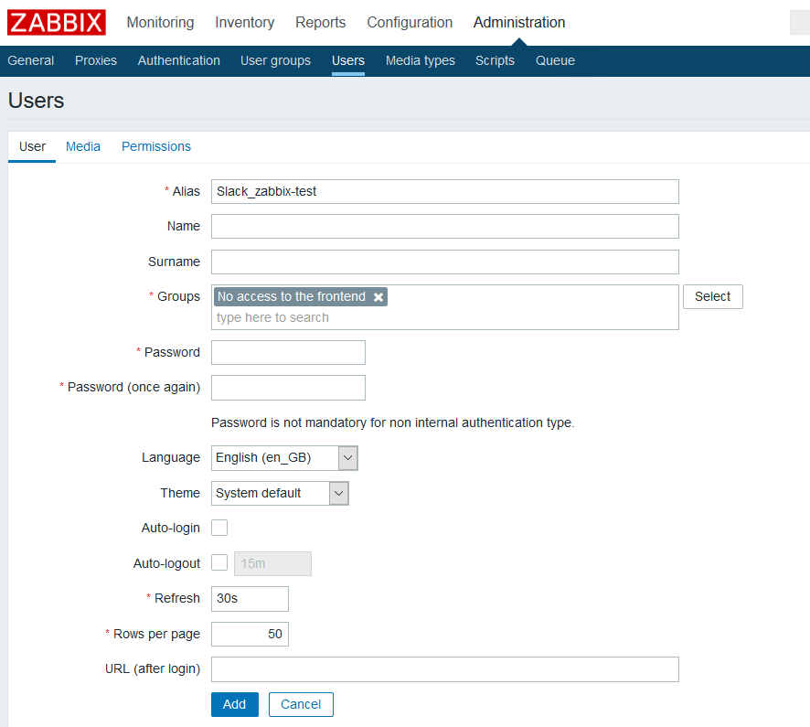

Go to the **Media** tab and add the Type “Slack” and Send to should be your channel name, so for my case it is #zabbix-test:

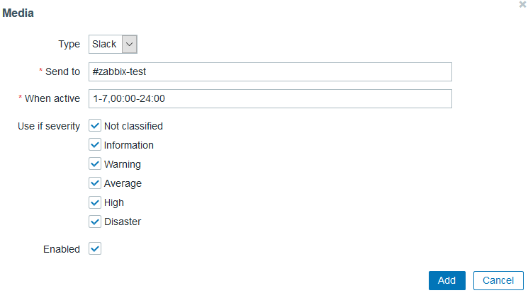

Leave all the severity levels default, we will define what triggers cause notifications with **Actions**. Add the Media and add the user:

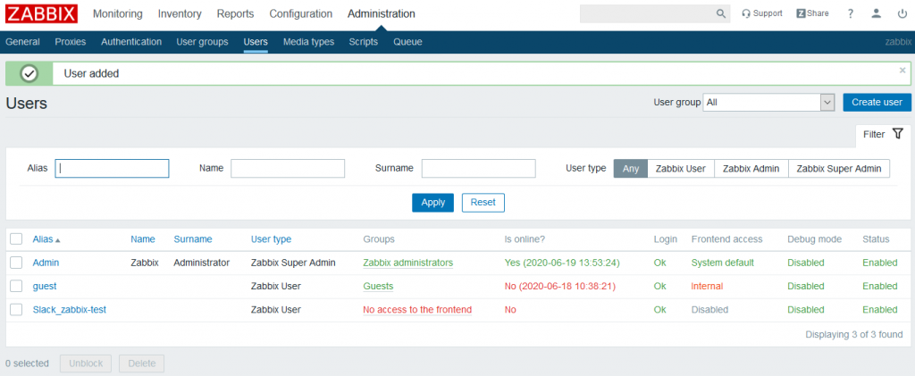

This sets up all of the routing needed to get notifications to Slack, now we just need to setup triggers to cause notifications. Navigate to **Configuration > Actions** and in the top right corner click **Create action**:

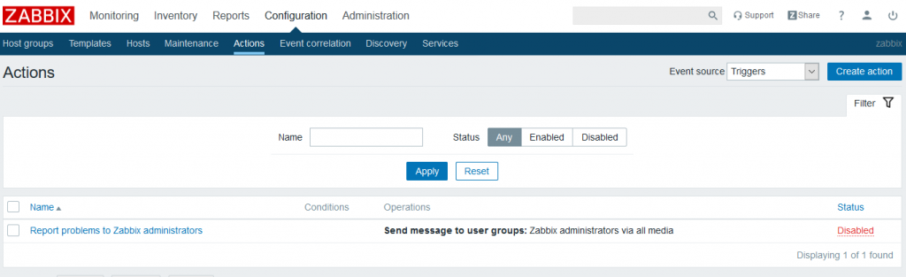

Set the **Name** to “Report to #zabbix-test Slack” or whatever you named your channel. This is where you clearly define what triggers will cause notifications to go to Slack. The easiest way to keep your Zabbix system under control is to use Tags here. I’ll set mine to “Tag value” and have the name be “*#slack_zabbix-test*” “equals” “1”. This means any tag with the name of *#slack_zabbix-test* and the value of 1 will be sent to the Slack channel #zabbix-test.

**Make sure you click the Add button under the New Condition, otherwise it wont take.**

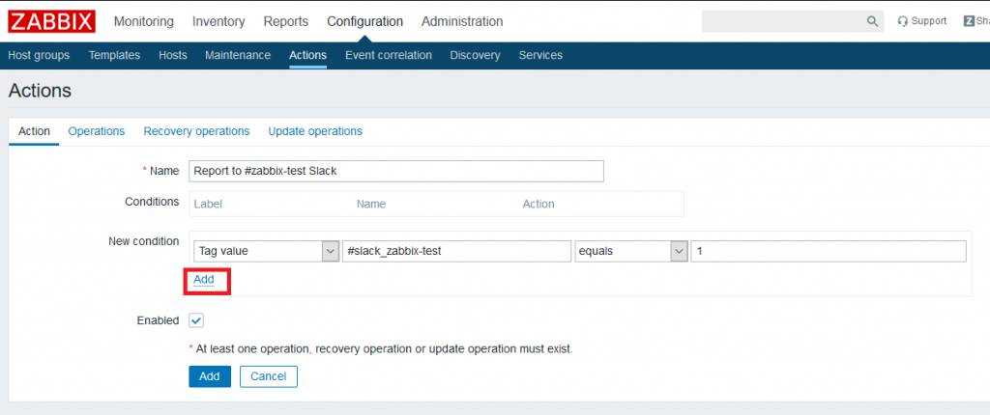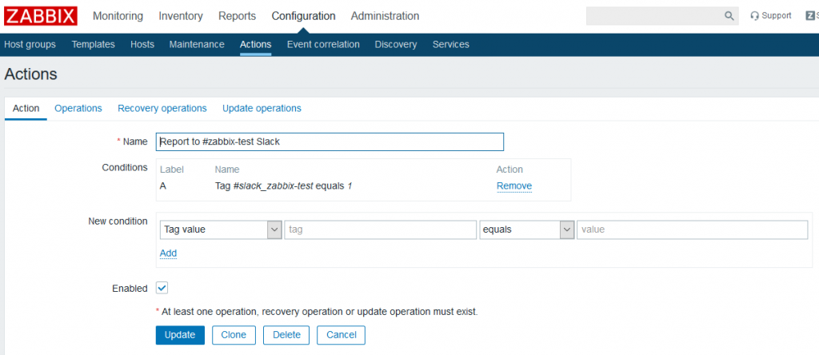

Before this is completed, you need to open **Operations** and on the **Operations** section click New. Next to Send to Users click Add and click the Slack_zabbix-test user that was created to communicate with the Slack channel.

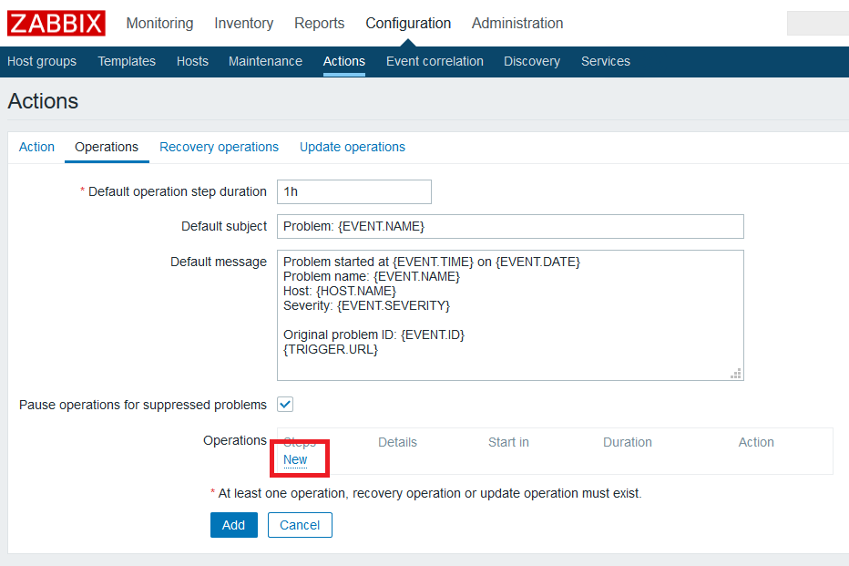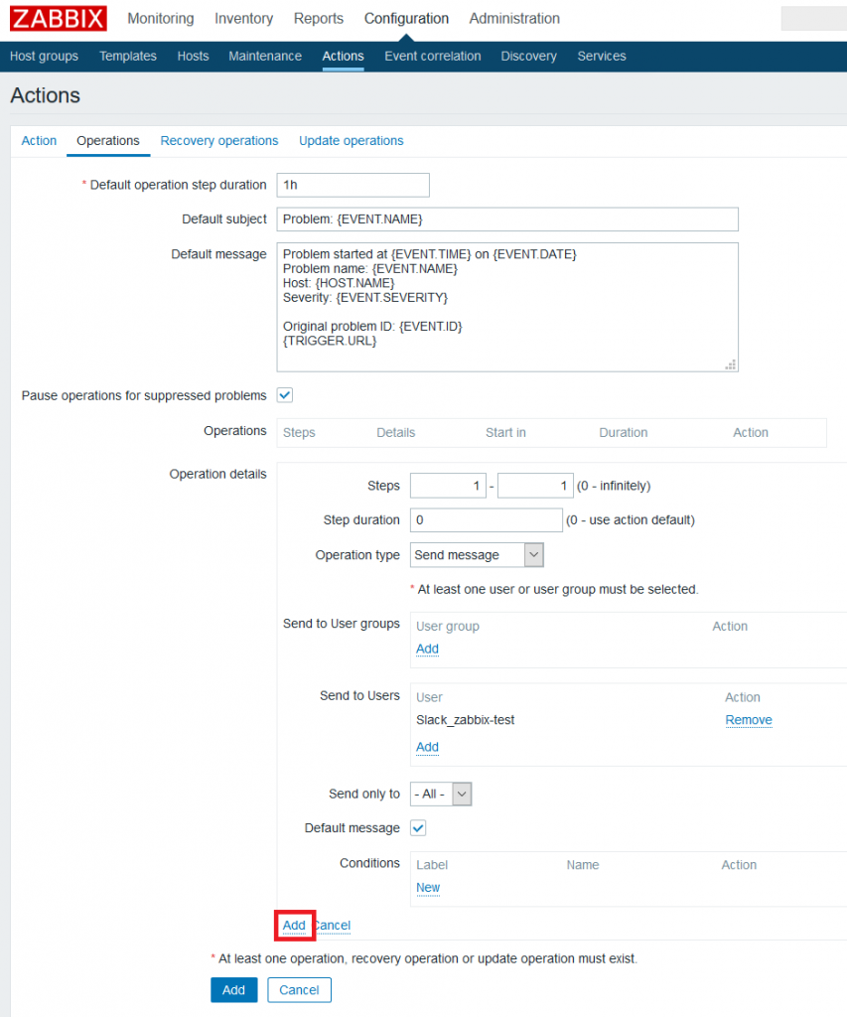**Make sure you click the Add button under the Operation details, otherwise it wont take.**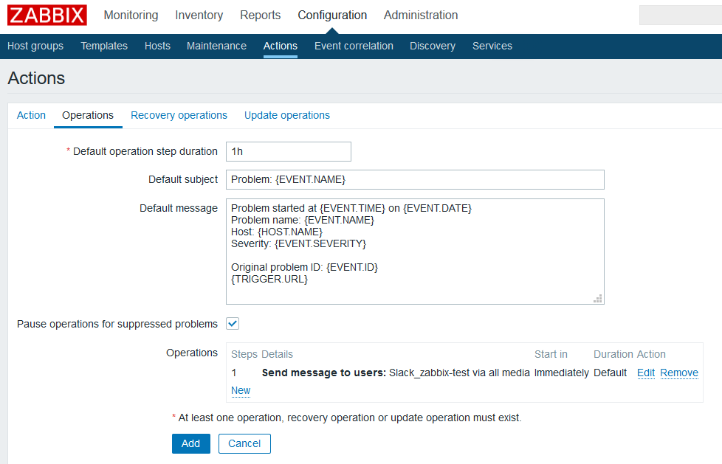

Now click **Recovery operations** and set **Operation Details > Operation type** to “Notify all involved”:

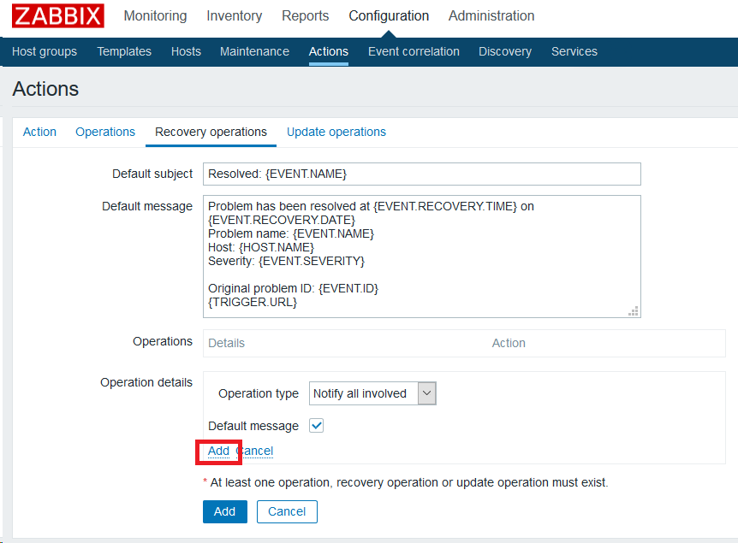

*Double check that you clicked Add on every field. It’s really easy to mess this up… it’s not very intuitive.*

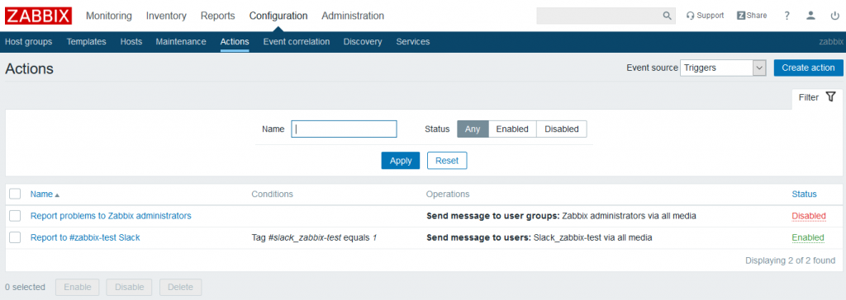

Everything should be setup at this point. Just click Add and it should immediately become active. We still need to setup a trigger with the correct tag, so let’s do that and see if it works.

## Testing

I’m going to test my system with the Ashly amplifier template that was covered in [this post](http://monitoreverything.net/2020/06/18/monitoring-ashly-protea-amplifiers-with-zabbix/). I went to **Configuration > Templates > Template Ashly Amplifier > Discovery rules > Trigger prototypes** and selected **Channel {#CHANNELINDEX} is too hot**. This will be the same for any trigger on Zabbix though.

Click on **Tags**:

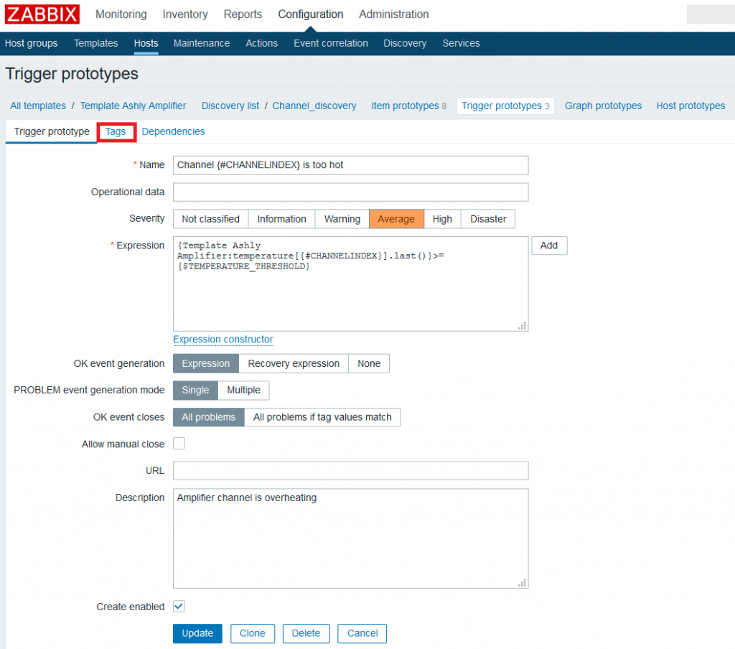

Create a tag “#slack_zabbix-test” or whatever you set your condition for in the Action we created. I set the value for 1 since that is required for the condition to work.

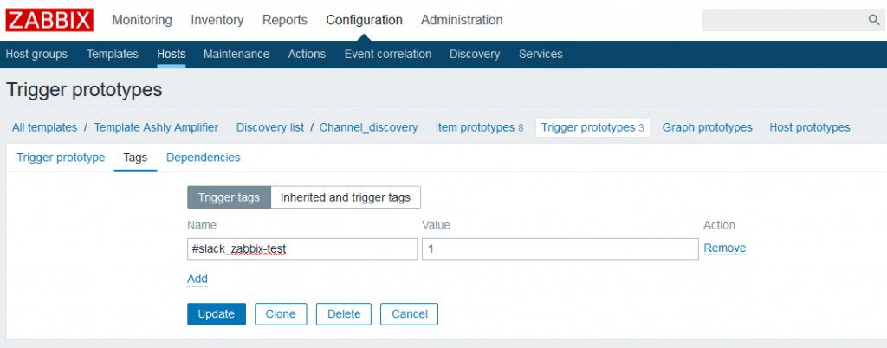

Now just click Update. At this point everything should be working. Let’s force a problem by making the Ashly template macro excessively low. Navigate to **Configuration > Templates > Template Ashly Amplifier > Macros**. Let’s set {$TEMPERATURE_THRESHOLD} to a value below the current temperature of the amplifier (you can find this in **Monitoring > Latest Data**). In my case I will do 30:

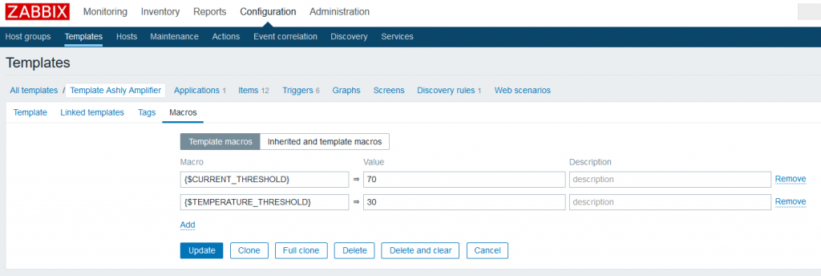

Click Update then head over to **Monitoring > Problems** and make sure a Ashly amplifier host is selected. After a minute or two you should see the problems start. If you look under **Actions** you will see it also sent a notification to Slack.

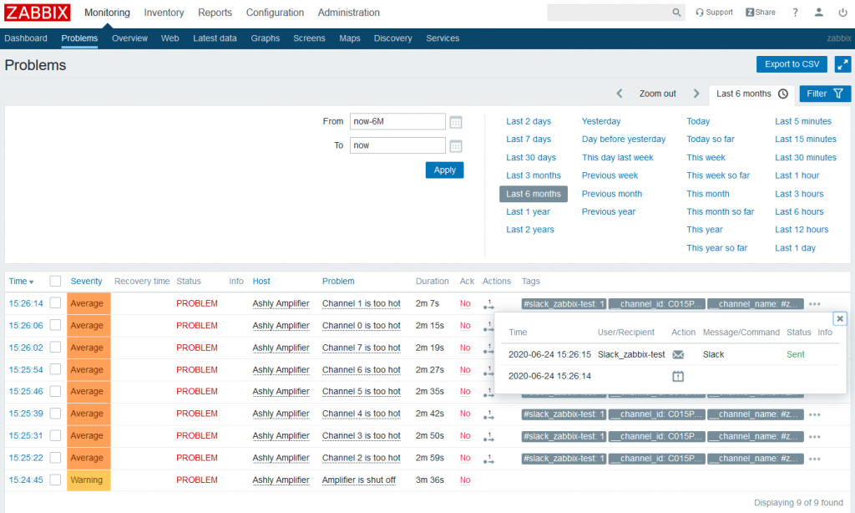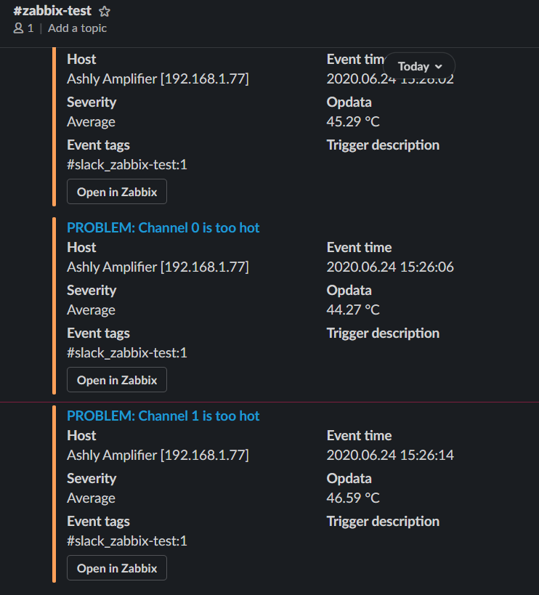

It look’s like everything is working as expected. Now set the macro back to something reasonable and watch the problems resolve in Zabbix and Slack.